TEXT FORMATING

**Objective**:

* text formatting, fonts, bold, italic, underline...
* Header / Footer

# 1 - Individual work. 15 min

* Create a new **document** in Microsoft Word
* Insert a **header**: your name that is centered aligned, and your class that is right aligned
* Insert a **footer**: the lesson title that is centered aligned
* Copy the **table** below to your document
* Complete th**e right column** with the questions and the required style

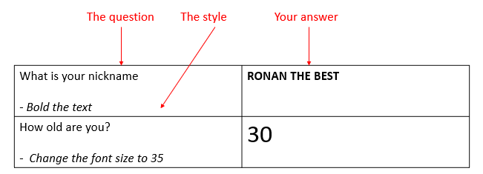

# 2- Group work (group of 4). 05 min

* Compare your work
  + Did you all succeed?
  + Help each other to understand all the objectives

# 3- Self-evaluation. 10 min

* Complete the evaluation to evaluate your progress

|  |  |
| --- | --- |
| What is your nickname?  *Bold the text* | **Kdek** |
| How old are you?  *Change the font size to your answer* | 19 |
| What color do you like?  *Change the color of the text to the color you*  *entered* | Blue |
| What would be your favorite job if you could do anything?  *Underline the text* | Web Developer |
| Where do you plan on living when you start your career?  *Italicize the text* | *Countryside* |
| What is your favorite food?  *Center aligns the text* | Chicken |
| What is your favorite sports team?  *Insert a bullet before the text* | * Visakha |
| What is your favorite holiday?  *Insert a custom bullet before the text* | * Sleep |
| What is your least favorite holiday?  *Double underline the text* | Thursday |
| What is the last movie you watched?  *Change the text to uppercase* | MASHA |
| Do you prefer to work as a team or alone?  *Change the font type* | Alone |

# EVALUTION GRID

|  |  |
| --- | --- |
| Objective | Evaluation (YES / NO) |
| **TEXT FORMATTING** | |
| Set text bold |  |
| Set text underline |  |
| Set text uppercase |  |
| Set text double underlined |  |
| Set text italic |  |
| Set text color |  |
| Align text left, center, right |  |
| Change font |  |
| Change font size |  |
| Header foot | |
| Create header / footer |  |